First point: ie colibactin to SBS88 mutation
At what level of colibactin exposure can mutational signature analysis reliably detect SBS88?
The paper addressed this via sensitivity simulations, injecting synthetic SBS88 mutations into real tumour genomes using a Gaussian distribution, then re-running signature attribution.

SBS Signature Profiles
A 96-row CSV where each row is one trinucleotide mutational context (e.g. A[C>A]A). Columns contain the probability that each context is mutated by each signature. Four signatures were used:
- SBS88_GRCh38
- SBS1_GRCh38
- SBS5_GRCh38
- SBS18_GRCh38

The SBS profiles define a probability distribution over 96 contexts. Sampling from this distribution generates a synthetic mutational spectrum for a given signature.

Method

Data Preprocessing
The SBS profile CSV was loaded and the Context column reordered to match the standard mutational signature convention (ordered by the substitution type first, then flanking bases). A composite 'Normal Colon' background signature was constructed as a weighted mixture of typical of healthy colonic epithelium:
Normal Colon = 0.4 x SBS1 + 0.4 x SBS5 + 0.2 x SBS18

Core Sampling Function
The foundation of the simulation is a function that draws a synthetic mutational spectrum from a weighted mixture of SBS88 and the Normal Colon background:
final_distrib = a * SBS88 + (1 - a) * Normal_Colon
counts = random.choices(range(96), final_distrib, k=n_mutations)
Where a is the proportion of mutations attributable to SBS88 and n_mutations is drawn from the TCGA distribution of real per-sample mutation counts.

Probability Distribution Models
Different patients have different levels of colibactin exposure, so a single fixed value is unrealistic. Three distributions:
Gaussian (Normal) Distribution
a ~ N(mean_a, 0.1 x mean_a)
This directly replicates the methodology in Senkin et al. (2025). The mean is the target injection level and the standard deviation is fixed at 10% of the mean - so at 5% injection the std is 0.5%. Values are clipped to [0, 1].
Beta Distribution
a ~ Beta(alpha, beta) parameterised by mean and variance
The Beta distribution is naturally bounded between 0 and 1, removing the need for clipping. It is parameterised to have the same mean and variance as the Gaussian. At low injection levels (1%) the Beta is more appropriate because the Gaussian places probability mass below zero which gets clipped, distorting the effective distribution.
Log-Normal Distribution
a ~ LogNormal(log(mean_a), 0.3)
The log-normal is right-skewed: most samples have low SBS88 exposure but a tail of samples have very high exposure.

Simulation Sweep
Each distribution was run at five injection levels: 1%, 5%, 10%, 15% and 20% of total mutation burden. At each level, 200 independent trials were run, each using a mutation count drawn from the TCGA sample distribution. This produced a (200, 96) matrix of synthetic spectra per distribution per injection level

Evaluation Metric: Cosine Similarity
Each synthetic spectrum was compared to the true SBS88 profile using cosine similarity:
cosine(a, b) = (a . b) / (||a|| x ||b||)
A value of 1.0 means the simulated spectrum is identical to SBS88. A value near 0 means no similarity. Higher cosine similarity at lower injection levels indicates the distribution model produces spectra that more faithfully retain the SBS88 signal even when it is diluted into a background.

Results
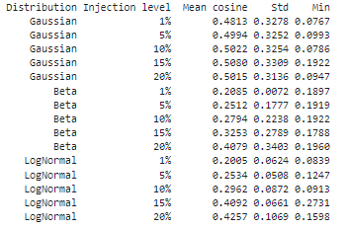

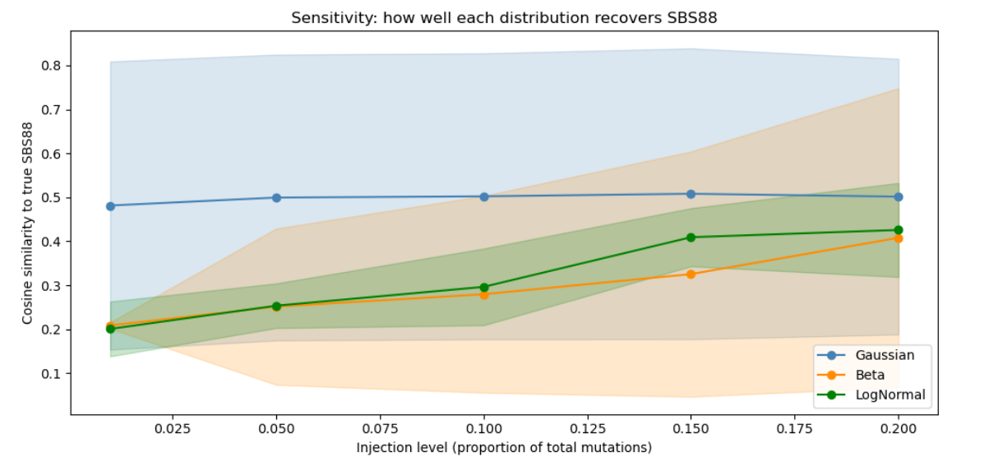

Line Plot
The line plot shows mean cosine similarity vs injection level for each distribution, with shaded regions representing one standard deviation. Key observations:
- Gaussian: Consistently highest mean cosine similarity across all injection levels (0.48-0.51). It does not increase much from 1% to 20%. There is much high variance (std around 0.32)
- Beta: Lowest mean cosine overall (0.21 at 1%), rising to 0.41 at 20%. The very low std at 1% (0.007) shows that Beta is extremely consistent - every trial produces a similar spectrum - but that spectrum has low SBS88 content because the distribution concentrates tightly around the low mean.
- Log-Normal: Intermediate mean cosine, rising from 0.20 at 1% to 0.43 at 20%. Lower std than Gaussian, indicating more consistency than the Gaussian model. The right skew means some trials inject considerably more than the mean, which inflates the average cosine at higher levels.

Boxplot Distribution

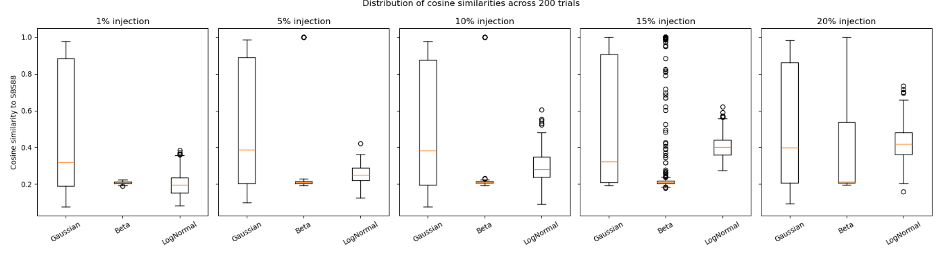
The boxplots at each injection level confirmed that Gaussian has the widest spread of cosine values - consistent with its high variance. Beta is the tightest. Log-Normal shows an intermediate and gradually widening spread.

Interpretation
The Gaussian distribution produces the highest mean cosine similarity, consistent with it being the model used in the original paper. I don’t really know what biologically is best any ideas??

